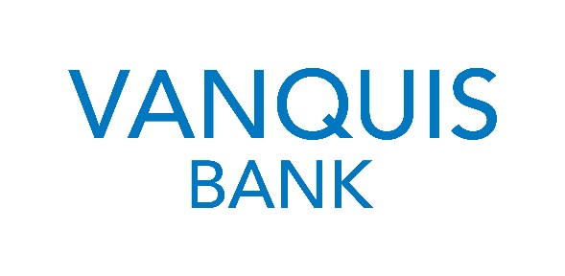

The Vanquis Social Impact Fund (Kent & Medway) 2021
Guidance Notes

Kent Community Foundation is proud to be working with Vanquis in an exciting grants initiative. As part of Vanquis’ commitment to Kent and Medway, we are delighted re-open the Vanquis Social Impact Fund which aims to support social inclusion. The programme will invest in activities that seek to alleviate the underlying problems that prevent social inclusion and enjoyment of a full modern life. The Fund will distribute £55,000 in grants, of between £1,500 and £7,500.

Fund Details

Who can apply?
Community groups, charities, social enterprises or other charitable organisations from the voluntary sector that:

- Have a constitution or other relevant governance document
- Have a management committee/board of directors/trustees of at least three unrelated people
- Have a bank account under the name of the group with at least two unrelated signatories
- Provide a signed copy of your organisations most recent bank statement
- Are based in and supporting people living in Kent and Medway (as defined by ME postcodes)
- Have an average annual income of £250,000 or under based on the last three years.
Priority will be given to small, community organisations in areas of social, financial and welfare disadvantage.

Size of Grant:
The minimum request is £1,500. The maximum is £7,500. Whilst the grant can be used to part-fund a wide range of activities, we like to see the impact our support is having. Accordingly, we prefer for our grant to equal at least 50% of the total cost of the activity or project within the criteria specified below. Only one application per organisation can be considered.

What can the Fund support?

The Vanquis Social Impact Fund (Kent & Medway) will support organisations working at a local level to address the following issues in their communities:

Digital Skills - developing or improving digital skills to enhance learning outcomes, access to employment opportunities or access to services.
Money Advice – supporting financial wellbeing by helping people to manage their money and tackle financial problems . If you are giving advice, it must be independent, impartial and confidential.

The fund is particularly interested in how work supports marginalised communities and/or those who face barriers to accessing mainstream support and services.

Types of activities that can be funded
The grants panel will look to fund projects and activities that are addressing need identified through consultation and/or engagement with potential beneficiaries and have a clear focus on the positive results they plan to achieve. Projects need to be inclusive of people in the locality regardless of their background, offer wider benefit and be cost effective.

Exclusions
Grants will not be awarded to or for:
- Commercial organisations
- Sponsorship (including sports kit) or marketing appeals
- Individuals – including students
- Food banks (unless they are part of the Trussell Trust network)
- Mainstream activities and statutory requirements of hospitals and medical centres (including NHS Trusts), universities and colleges
- Establishment/preservation of endowment/welfare funds
- Organisations that redistribute funding for subsequent grant-making to other organisations and/or individuals
- Expeditions or overseas travel
- Single religious or ethnic groups – we don’t support organisations who are promoting their own values. We would however consider supporting the activities of such organisations if they are aimed at supporting the wider community in accordance with these guidelines
- Political or military groups or activities – although we would consider supporting organisations who support veterans in accordance with these guidelines
- Capital appeals for building projects, e.g. for rebuilding a community centre, heritage centres, visitor centres, museums, theatres or places of worship
- Historic restoration/historic publications
- Overseas organisations – this is about supporting our local communities
- Animal welfare organisations
- Projects currently in receipt of funding through Vanquis or Provident Financial Group
- Organisations that have income over £250k in the most recent financial year

When can you apply?

The fund opens 14 June and the deadline to apply is 5pm 16 July 2021.

Funding will be awarded in September 2021.

Grant Making

How do you apply for a grant?

To apply you need to complete an online application form available from https://kentcf.org.uk/funding. You will also need to submit required documentation as set out in the online application guidelines and Kent Community Foundation Terms & Conditions.

We expect this programme to be highly oversubscribed so we strongly recommend you also seek alternative sources of funding for your project to avoid disappointment.

We strongly suggest you submit your application at your earliest opportunity. Incomplete applications won’t be considered.

What happens after you’ve applied?
We will assess your application and may need to contact you and your referee during this time. Any community groups seeking funding by way of a grant from the Fund will submit a full application to Kent Community Foundation which will be subject to Kent Community Foundation’s standard internal assessment procedures. Kent Community Foundation reserves the right to make any necessary further enquiries about the applicant. This assessment will take place prior to any group being submitted to the Fund grants panel for approval.

Monitoring
If you are successful, the grant letter/email will include any additional conditions set by the panel and/or the grant payment. The grant must be spent within 12 months of the date of our letter confirming the grant. You must also complete an end of grant Monitoring report telling us how the grant has been spent and what was achieved. The deadline for doing so will be specified in your offer letter. Please note that failure to provide appropriate monitoring information will exclude your organisation from applying to future Vanquis grants schemes.

If your bid is not successful, we will let you know the reasons for declining it. Please note we have limited funding available and we are not able to fund every application we receive, no matter how deserving the project is. The decisions made by the grants panel are final.

Publicity
If your application is successful, you will be required to credit support from the Vanquis Social Impact Fund and Kent Community Foundation on all materials related to the funded work. Successful projects will be required to be available for a potential Monitoring visit from funders.

To Apply

Click https://kentcf.org.uk/funding for access to the online application.

If you require more information about this fund please contact Kent Community Foundation: email admin@kentcf.org.uk

