**Embracing Adaptability: A Journey of Growth and Community Building**

When I first received the Kent Community Foundation Learning Journeys Fund, the task ahead felt huge and a bit overwhelming. Organising such a significant project seemed out of reach. However, by breaking down the steps and tackling each challenge bit by bit, I managed to navigate the complexities and achieve some impressive successes.

My journey began with a focus on adaptability. Knowing that staying flexible in the face of challenges was crucial, I collaborated closely with my colleagues who had experience undertaking similar tasks. They helped me break down what needed to be done, ensuring we kept moving forward. This approach sparked creative solutions and underscored the importance of teamwork.

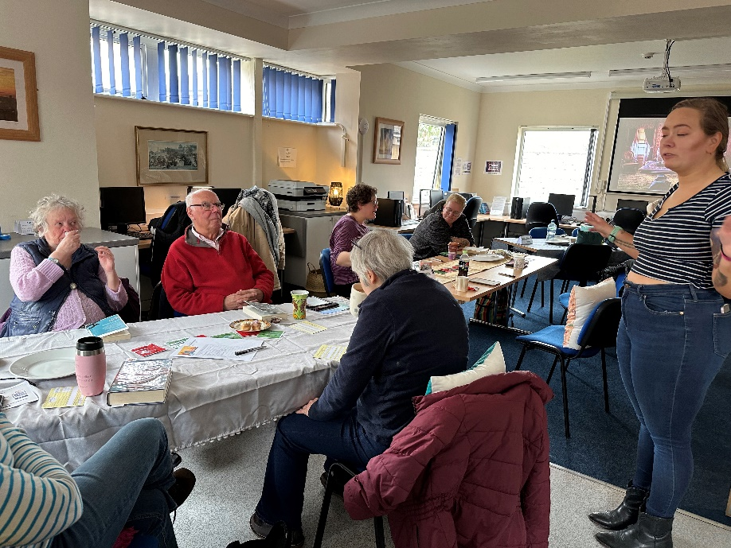

The above image is of our inaugaral Silent Book Club where I was explaining the process of the session.

One of the standout achievements was my ability to reach a variety of community members through our consultation events. These events drew a great turnout and encouraged constructive engagement from participants with diverse viewpoints. The enthusiastic participation demonstrated the strong sense of community they have built and the potential for even more growth. The feedback received was incredibly valuable, offering insights into what the community envisions for the future.

Moreover, this journey has taught me a great deal about myself. I’ve learned about my confidence and my ability to coordinate and create projects that support the community. Seeing the tangible benefits of our efforts has reinforced my belief in the power of adaptability, teamwork, and community engagement. It’s been a rewarding experience, highlighting the importance of staying flexible and responsive to the needs of those we aim to serve.

Moving forward, I know I can achieve what sometimes feels impossible. I will continue pushing the boundaries of my professional development in ways that support the community. By embracing new challenges and staying adaptable, I aim to keep making a positive impact and fostering a sense of belonging and enrichment for everyone.