We have compiled a list of trusts, foundations and grant-making bodies who have the capacity to cover capital funding projects. Sub-sections are included where organisations only fund specific purchases, for example a minibus.

General Capital Funding

The Tudor Trust
Tudor makes grants, and provides other types of support, to voluntary and community groups working in any part of the UK. They particularly want to help smaller, community-led organisations that work directly with people who are at the margins of society: organisations
that support positive changes in people’s lives and in their communities. Tudor want to respond
flexibly to your ideas and energy, and to fund effective organisations working to high standards.
The trust is willing to complete core funding as well by supporting people between one to three years, their average years of support is two. Within this funding stream the trust offers capital project funding across multiple purchases.
For more information: www.tudortrust.org.uk

Garfield Weston
The Foundation supports a broad range of charities across the UK that make a positive difference. Funding a wide range of causes and charities, our grants vary according to the size of the charity and the work being undertaken.
For more information: www.garfieldweston.org

The Henry Smith Charity
Henry Smith Charity has multiple streams of funding which can range in core running costs and capital with values from £500 up to £400,000 in some cases. The organisation have recently opened a Housing funding stream allowing groups and organisation to apply to support Housing First schemes across the country.
For more information: https://www.henrysmithcharity.org.uk/

Clothworkers Foundation
Their one-off grants are for the purchase of specific and pre-determined capital item(s), or service(s) for a project. "Capital" means tangible items or work; things that can be seen and used. This includes:

- Buildings- For example purchase, construction, renovation, refurbishment, redecoration.
- Fittings, fixtures, and equipment- For example office equipment, sports or gym equipment, digital or audio-visual equipment, camping equipment, garden equipment, specialist therapeutic (but not purely medical) equipment.

- Soft or hard furnishings, bathroom/kitchen fittings and fixtures - Please note that they do not fund equipment which will be purchased on an ad-hoc basis or which will be given to service users as part of your organisation's everyday operations.
- Vehicles - For example minibus, car, caravan, people-carrier, 4X4. Please note that it is rare for them to fully fund brand new vehicles

For more information: https://www.clothworkersfoundation.org.uk/

The Percy Bilton Charity
Only registered charities in the U.K. whose primary objectives are to assist one or more of the groups included below.
The charity will consider capital funding for the following projects and schemes: disadvantage/underprivileged young people (under 25); people with disabilities and older people over 60. One off payment for capital expenditure of approximately £2,000 and over (the majority of grants fall within the range of £2,000 to £5,000). Preference is given to specific items of furniture and equipment (excluding office items) which the charity can fund in their entirety.
Please bear in mind that the trustees prefer to use the charity's funding to complete projects in order to maximise effectiveness and ensure grants are taken up as quickly as possible. This means that minibuses, building and refurbishment works are only considered in the final stage of the fundraising appeal. Please apply once you have a shortfall of £15,000 or less.
For more information: http://www.percy-bilton-charity.org

The Bernard Sunley Charitable Foundation
Offering one-off grants for capital projects, i.e. new buildings, major refurbishments, transport and equipment. Rented premises are expected to have a lease of at least 10 years. Applications for transport should be for new, not used, vehicles. Applications for equipment should be for single, high cost (£5,000 and over), durable items (for exclusions, see website linked below).
Where grants are made, the projects are expected to be self-financing thereafter.

For more information: http://www.bernardsunley.org/index.html

Small-scale Capital Funding

Reaching Communities England
Flexible funding over £10,000 for up to five years to organisations in England who want to take action on the issues that matter to people and communities.
For more information: https://www.tnlcommunityfund.org.uk/funding/programmes/reaching- communities-england#section-1

B&Q Community re-use
B&Q stores have been donating unsellable materials and products to their local community groups for many years. It's a great way to reduce waste whilst helping out the community. Some of this capital can be small but it will allow organisations to gain materials and products for free that have not been fully used or are completely new to reduce refurbishment costs.
For more information: https://www.diy.com/corporate/community/waste-donation/

Arts, Culture and Heritage

The Arts Council England
National Lottery Project Grants is their new open access programme for arts, museums and libraries projects. The fund will support thousands of individual artists, community and cultural organisations. Included in the community and cultural organisations they welcome capital applications as long as they link to the arts.
For more information: https://www.artscouncil.org.uk/projectgrants

Clore Dufflield Foundation
Decisions from trustees are in June and December. Grants range from £10,000 to in excess of
£1m, although larger grants are made infrequently. The majority of expenditure is for capital projects – only a small number of grants are made each year for programme funding.
Please note that organisations must be registered charities to be eligible for the Main Grants Programme, with the exception of local authority cultural organisations. Grants support the cultural sector, and in particular cultural learning and focus on museum, gallery, heritage and performing arts learning spaces.
For more information: https://www.cloreduffield.org.uk/home

Foyle Foundation – School Library Capital Funding
The Foyle School Library Scheme accepts applications from state funded schools in the United Kingdom. The scheme recognises that there is no statutory requirement for schools to have a library and that many school libraries are in a poor state through underfunding and underdevelopment. Encouraging children to read widely from an early age will provide a major boost to improving literacy levels, which is a key educational objective.
For more information: http://www.foylefoundation.org.uk/how-to-apply/state-schools.php

Land Buildings and Local Amenities

Biffa Awards – Community Buildings
Projects under the Community Buildings theme include those which improve buildings at the heart of their communities – such as village halls, community centres and church halls. They can

include building refurbishments and internal works to kitchens, toilets, roofs, flooring, window, doors and heating systems. Applications from churches must be able to demonstrate a wider community use and benefit – such as youth groups, special interest groups, exercise groups etc. Under this theme an applicant will have to show evidence of wider community use, involvement and consultation. The project site must be within five miles of a significant Biffa operation or within 10 miles of an active Biffa Landfill site.
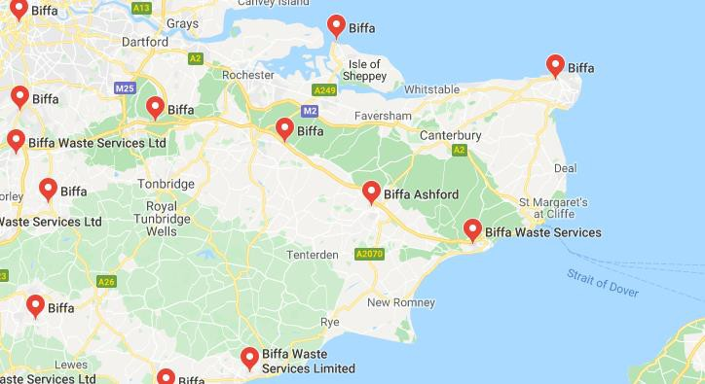

For more information: https://www.biffa-award.org/community-buildings/

Trusthouse Charitable Foundation
Trusthouse is interested in applications for capital projects at community centres in the most deprived urban areas and village halls in remote and economically deprived rural areas. Looking to support those at the heart of their community these are not just limited to the typical buildings but can include churches, sports facilities and activities throughout the week that the community can participate in.

For more information: http://trusthousecharitablefoundation.org.uk/grants/community- centres-and-village-halls/

The Rank Foundation – Pebble Grants Programme (UK)
UK registered charities and recognised churches which are raising money for capital projects (building work, refurbishment or the purchase of long-term equipment) or a one-off short term activity (such as an annual respite break or holiday for disadvantaged young people) can apply for funding through the Rank Foundation – Pebble Grants programme. To be eligible to apply the total project cost must be less than £1 million, the organisation must have an annual income of less than £500,000 and the organisation applying must already have raised a third of the total costs.

For more information: https://rankfoundation.com/pebble-grants/%C2%A0

National Churches Trust
We support a wide variety of projects through our grant programmes. From repairing a roof to helping to install an accessible toilet - and many other projects - our grants help keep churches open for worship and community activities and allow them to continue serve people in all sorts of ways. We now offer three types of grant - Cornerstone, Gateway and Foundation Grants for Maintenance. Full details can be found by going to the individual grant programme pages shown at the bottom of this page, which include important information about deadline dates.

For more information: https://www.nationalchurchestrust.org/our-grants

Recreation and Environment

Veolia Trust
The Veolia Trust can support the improvement of community buildings, outdoor spaces, play and recreation as well as biodiversity projects. Funding can be sought between £10,000 and
£75,000 and must fall within locations near Veolia activity – use the postcode checker on the website.

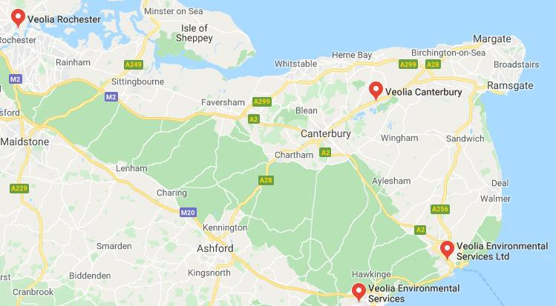

For more information: https://www.veoliatrust.org/funding/index.php?page=Our_Criteria_1

Biffa Awards – Recreation
Projects under the Recreation theme can include new play equipment; landscaping works, including boardwalks, trees and shrubs; skate parks; woodland walks; nature trails; outdoor

gyms; and building works within communal areas of sporting clubhouses (such as kitchen and toilet facilities) which have a wider community use and are not for the sole use of sports club members. It generally includes projects that benefit people within their free time. Under this theme an applicant will have to show evidence of wider community use, involvement and consultation. The project site must be within five miles of a significant Biffa operation or within 10 miles of an active Biffa Landfill site.

For more information: https://www.biffa-award.org/recreation/

True Colours Trust
The True Colours Trust is passionate about making a difference to the lives of children with special needs and their families and supporting people with life limiting and/or life-threatening illnesses.

The trustees are committed to supporting a large number of excellent local organisations and projects that work with disabled children and their families on a daily basis. This is done through the trust's small grants programme. It provides grants of up to £10,000 to help smaller organisations develop and deliver programmes for children, their siblings and families. It is open to applications at any time. Grants in this category are usually one-off contributions rather than multi-year grants for on-going revenue costs. The trustees are particularly keen to support projects around hydrotherapy pools, multi-sensory rooms, minibuses and specialised play equipment.

For more information: http://www.truecolourstrust.org.uk/small-grants-uk/

War Memorial Trust
War Memorials Trust grants support repair and conservation works undertaken following best

conservation practice. Almost all war memorials are eligible for support and custodians/owners can find information about eligibility and processes in this section of the website.

For more information: http://www.warmemorials.org/grants/

Minibuses and Transport

True Colours Trust
The True Colours Trust is passionate about making a difference to the lives of children with special needs and their families and supporting people with life limiting and/or life-threatening illnesses.

The trustees are committed to supporting a large number of excellent local organisations and projects that work with disabled children and their families on a daily basis. This is done through the trust's small grants programme. It provides grants of up to £10,000 to help smaller organisations develop and deliver programmes for children, their siblings and families. It is open to applications at any time. Grants in this category are usually one-off contributions rather than multi-year grants for on-going revenue costs. The trustees are particularly keen to support projects around hydrotherapy pools, multi-sensory rooms, minibuses and specialised play equipment.

For more information: http://www.truecolourstrust.org.uk/small-grants-uk/

Ford Britain Trust
You must apply by completing our application form. Please make sure you read our guidelines carefully before making an application. The guidelines will help you determine if your school or charitable organisation is eligible to receive a grant, understand how the application process works and complete your application form. Depending on the size of the grant you are seeking, not all the questions on the form will be relevant to you.

For more information: https://www.ford.co.uk/experience-ford/about-ford/ford-britain- trust/grant-application

Lord’s Taverners: Accessible Minibuses
The Lord’s Taverners provides a range of specially adapted minibuses for SEN Schools catering for young people (under 25 years old) with learning and physical disabilities. Each minibus costs in the region of £61,000. The customised minibuses are provided to enable schools to engage pupils in a range of sporting and recreational activities within the local community. Additionally, the minibus will be used to support the wider curriculum and help develop life skills.

For more information: https://www.lordstaverners.org/accessible-minibuses

Disabilities – Physical/Mental/Learning

The Baily Thomas Charitable Fund

The Baily Thomas Charitable Fund is a registered charity which was established primarily to aid research into learning disability and to aid the care and relief of those affected by learning disability by making grants to voluntary organisations working in this field. They do not normally fund minibuses except those for residential and/or day care services for the learning disabled.

For more information: http://www.bailythomas.org.uk/

Improving Technology and Systems

Paul Hamlyn Foundation – Tech for Good
In partnership with Comic Relief to deliver the Tech for Good funding programme. The programme supports charity organisations who are using technology to deliver new ideas and make their services more effective. After two successful co-funding rounds in 2017 and 2018, the organisation has extended the programme to 2021. Previous grants range between £45,000 and £55,000.
For more information: https://www.phf.org.uk/funds/tech-for-good/

